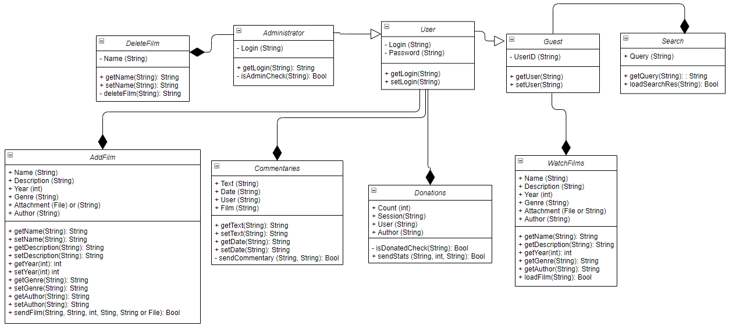

Pic. 1 - UML-diagram of program classes.